The whole Project is uploaded in Github :<https://github.com/Venkie07/Dog_Cat>  
  
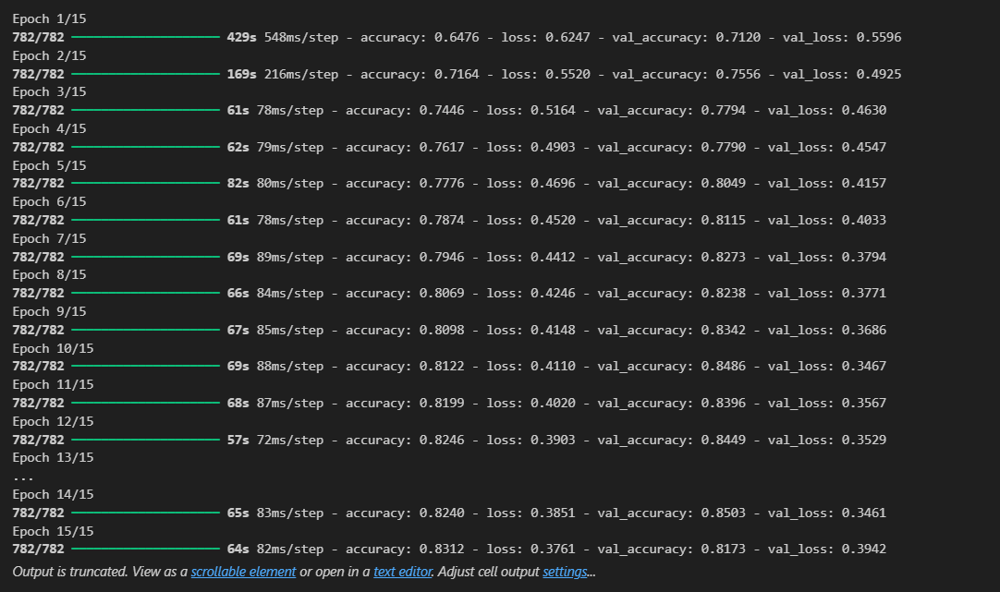

# I have Created 5 models in different platforms with increasing accuracy

Model_128_20epoch.h5 have the highest accuracy of 91%

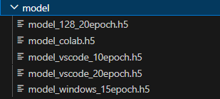

**CNN Model Prediction Report:**

================================================================

Models loaded successfully

================================================================

Real Image : cat

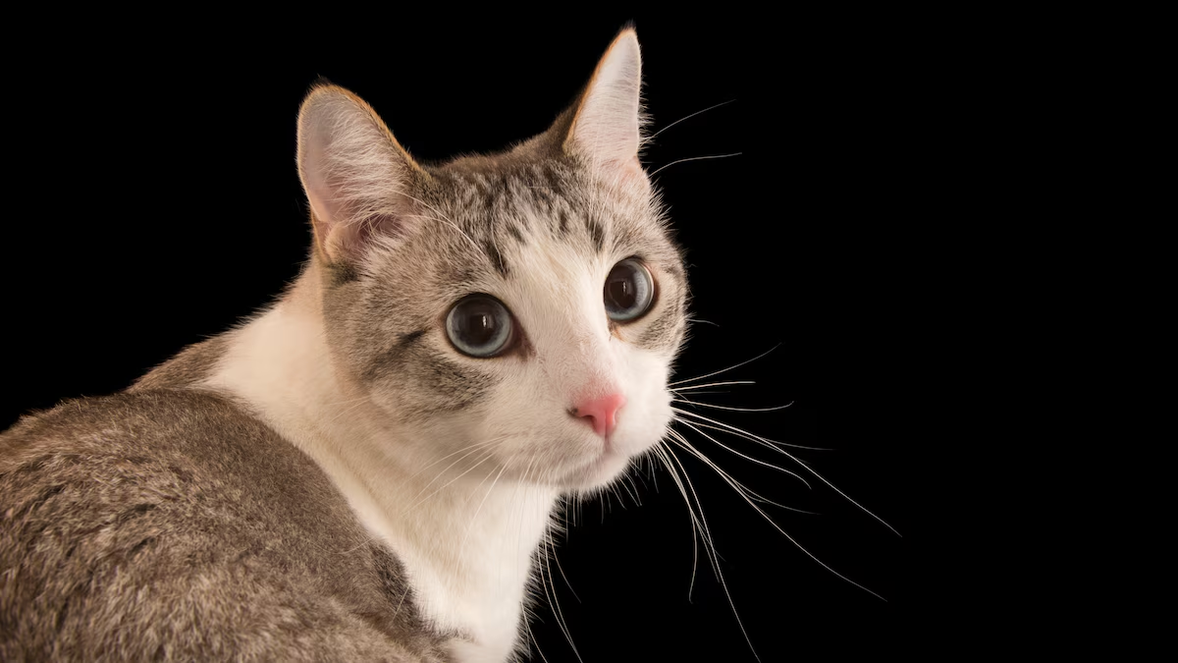

-----------------Result-------------------

Prediction of Model 1 : Cat

Prediction of Model 2 : Cat

Prediction of Model 3 : Cat

Prediction of Model 4 : Cat

Prediction of Model 5 : Dog

------------------------------------------

================================================================

Real Image : cat

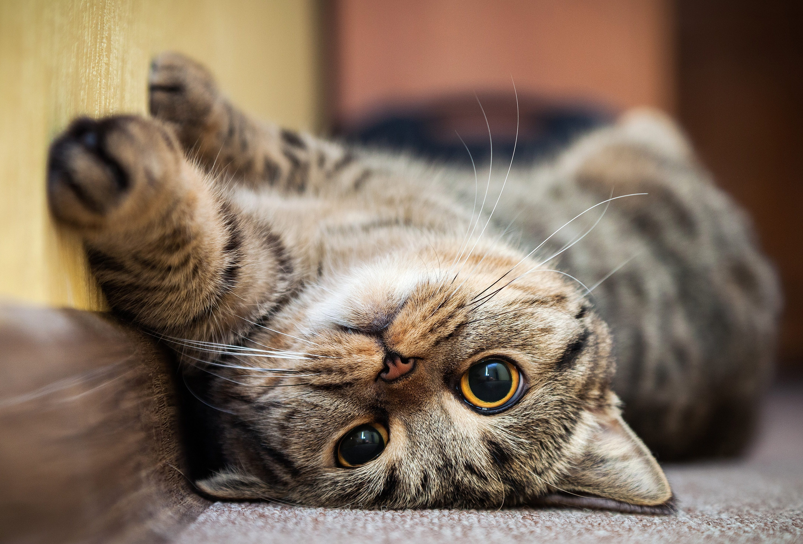

-----------------Result-------------------

Prediction of Model 1 : Cat

Prediction of Model 2 : Cat

Prediction of Model 3 : Dog

Prediction of Model 4 : Dog

Prediction of Model 5 : Cat

------------------------------------------

================================================================

Real Image : cat

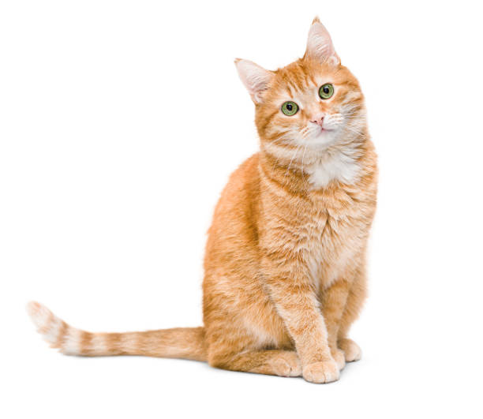

-----------------Result-------------------

Prediction of Model 1 : Dog

Prediction of Model 2 : Cat

Prediction of Model 3 : Dog

Prediction of Model 4 : Dog

Prediction of Model 5 : Dog

------------------------------------------

================================================================

Real Image : cat

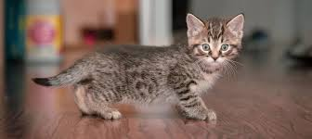

-----------------Result-------------------

Prediction of Model 1 : Cat

Prediction of Model 2 : Cat

Prediction of Model 3 : Cat

Prediction of Model 4 : Cat

Prediction of Model 5 : Cat

------------------------------------------

================================================================

Real Image : cat

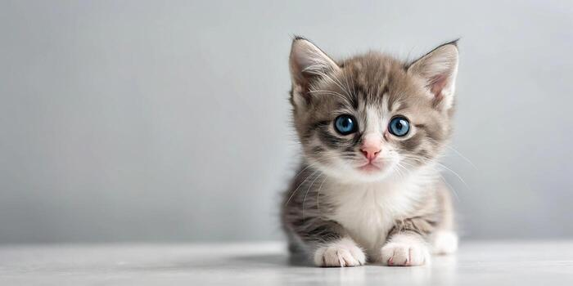

-----------------Result-------------------

Prediction of Model 1 : Cat

Prediction of Model 2 : Cat

Prediction of Model 3 : Cat

Prediction of Model 4 : Cat

Prediction of Model 5 : Cat

------------------------------------------

================================================================

Real Image : cat

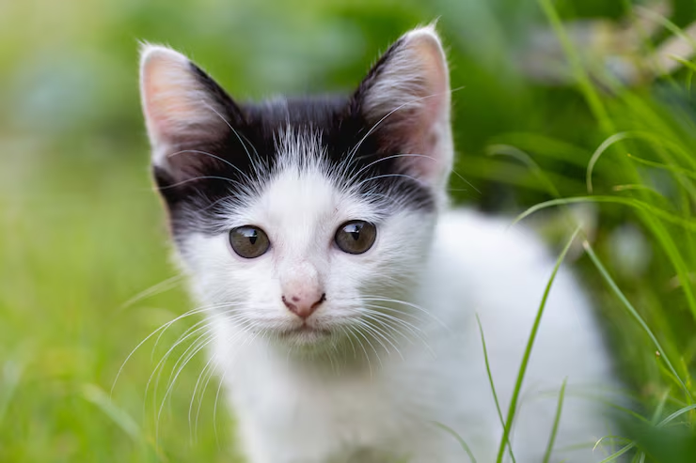

-----------------Result-------------------

Prediction of Model 1 : Dog

Prediction of Model 2 : Dog

Prediction of Model 3 : Dog

Prediction of Model 4 : Dog

Prediction of Model 5 : Cat

------------------------------------------

================================================================

Real Image : cat

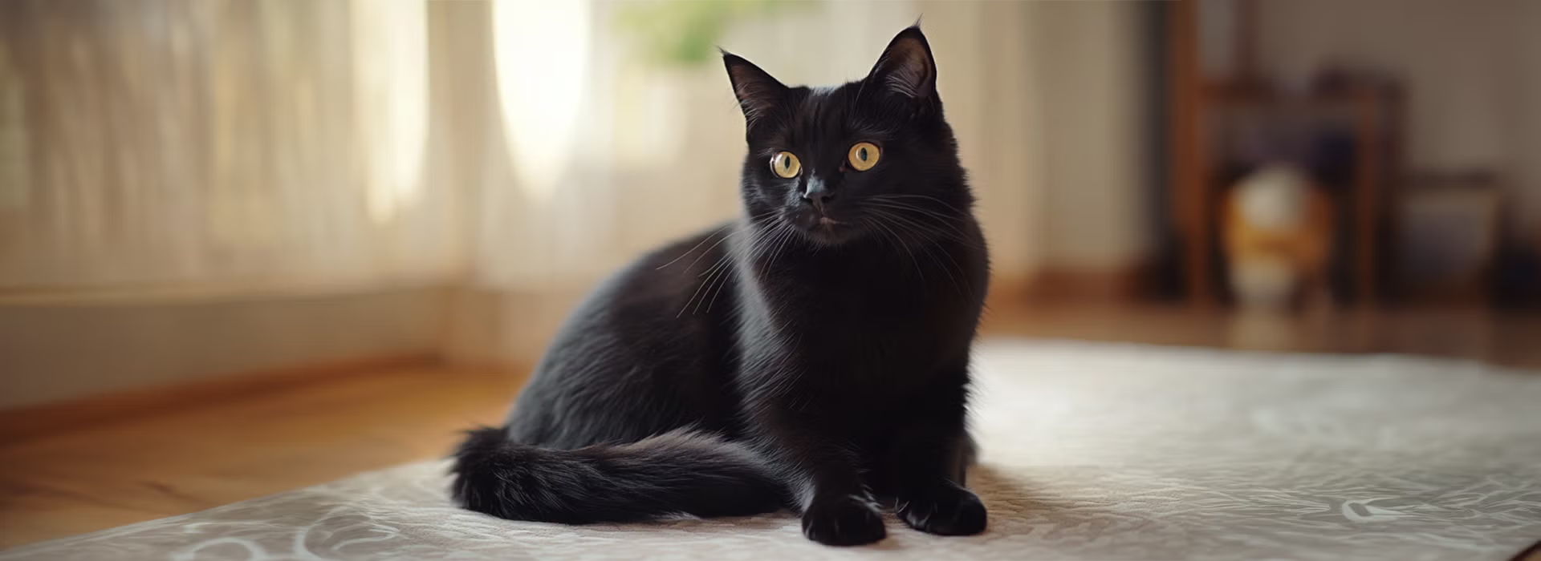

-----------------Result-------------------

Prediction of Model 1 : Cat

Prediction of Model 2 : Cat

Prediction of Model 3 : Cat

Prediction of Model 4 : Cat

Prediction of Model 5 : Cat

------------------------------------------

================================================================

Real Image : cat

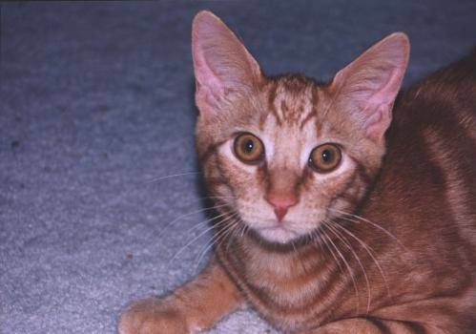

-----------------Result-------------------

Prediction of Model 1 : Cat

Prediction of Model 2 : Cat

Prediction of Model 3 : Dog

Prediction of Model 4 : Cat

Prediction of Model 5 : Cat

------------------------------------------

================================================================

Real Image : cat

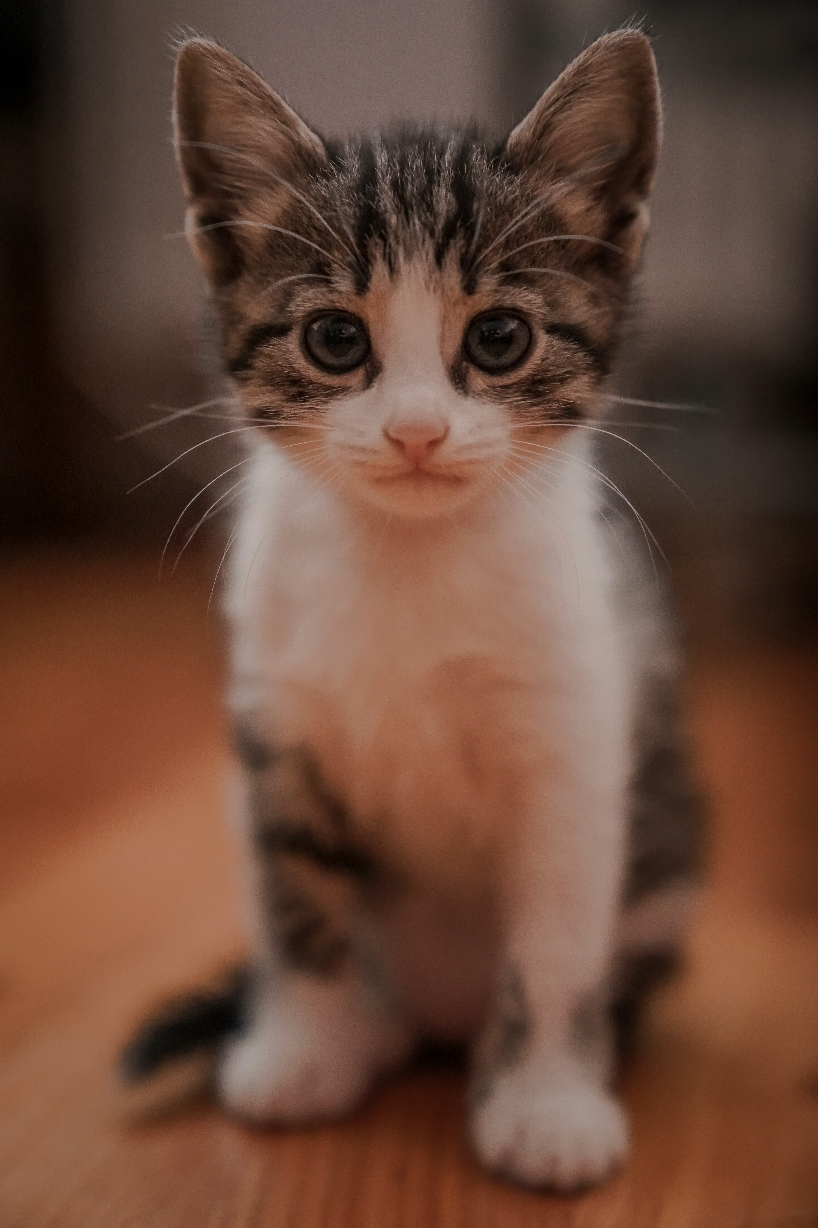

-----------------Result-------------------

Prediction of Model 1 : Cat

Prediction of Model 2 : Cat

Prediction of Model 3 : Cat

Prediction of Model 4 : Cat

Prediction of Model 5 : Cat

------------------------------------------

================================================================

Real Image : cat

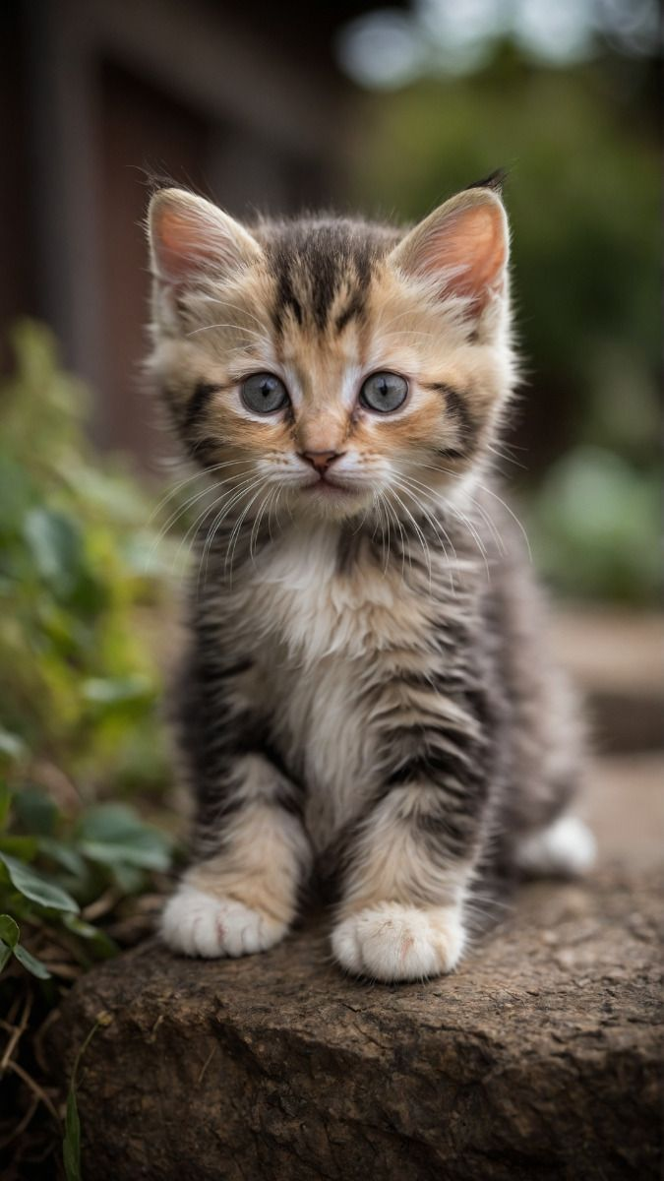

-----------------Result-------------------

Prediction of Model 1 : Cat

Prediction of Model 2 : Dog

Prediction of Model 3 : Dog

Prediction of Model 4 : Cat

Prediction of Model 5 : Cat

------------------------------------------

================================================================

Real Image : cat

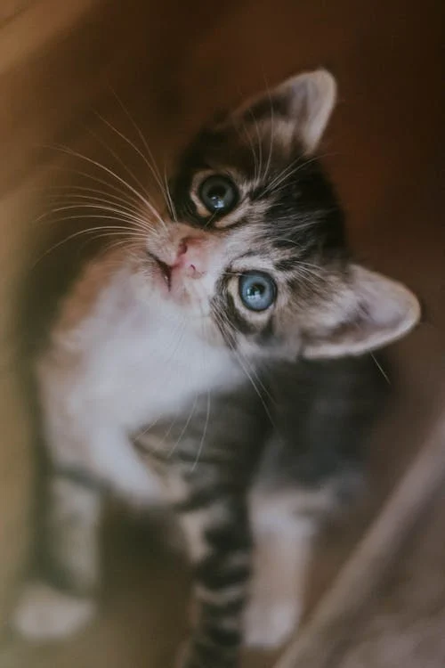

-----------------Result-------------------

Prediction of Model 1 : Cat

Prediction of Model 2 : Cat

Prediction of Model 3 : Cat

Prediction of Model 4 : Cat

Prediction of Model 5 : Cat

------------------------------------------

================================================================

Real Image : cat

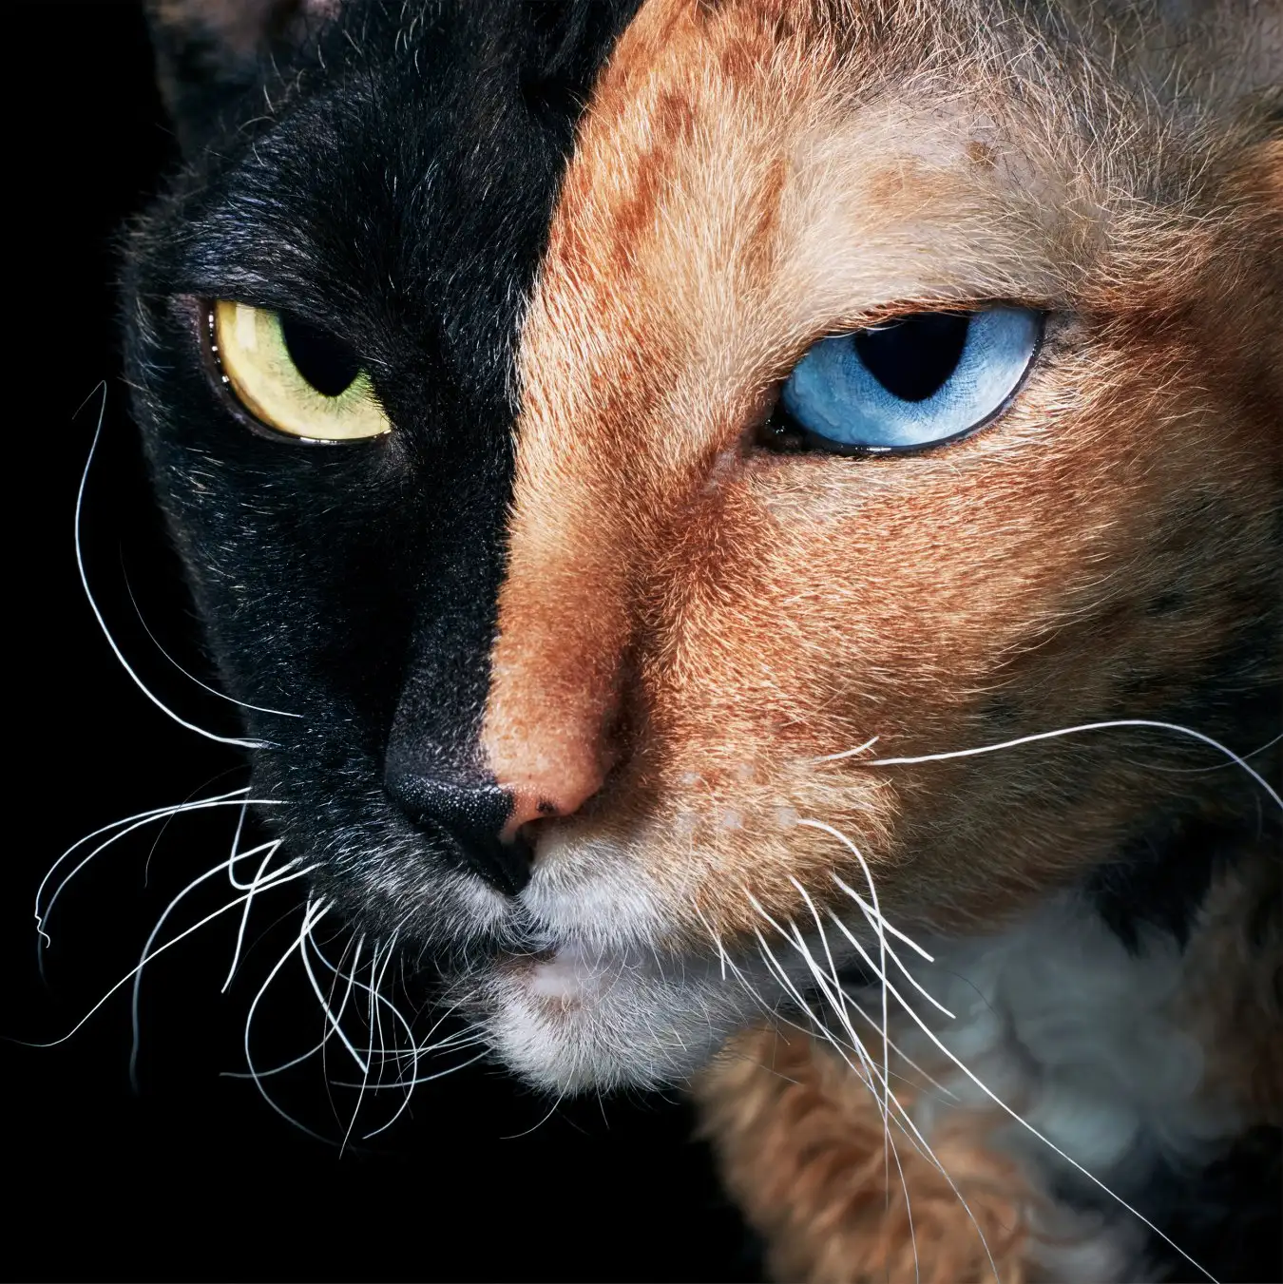

-----------------Result-------------------

Prediction of Model 1 : Cat

Prediction of Model 2 : Dog

Prediction of Model 3 : Dog

Prediction of Model 4 : Cat

Prediction of Model 5 : Cat

------------------------------------------

================================================================

Real Image : dog

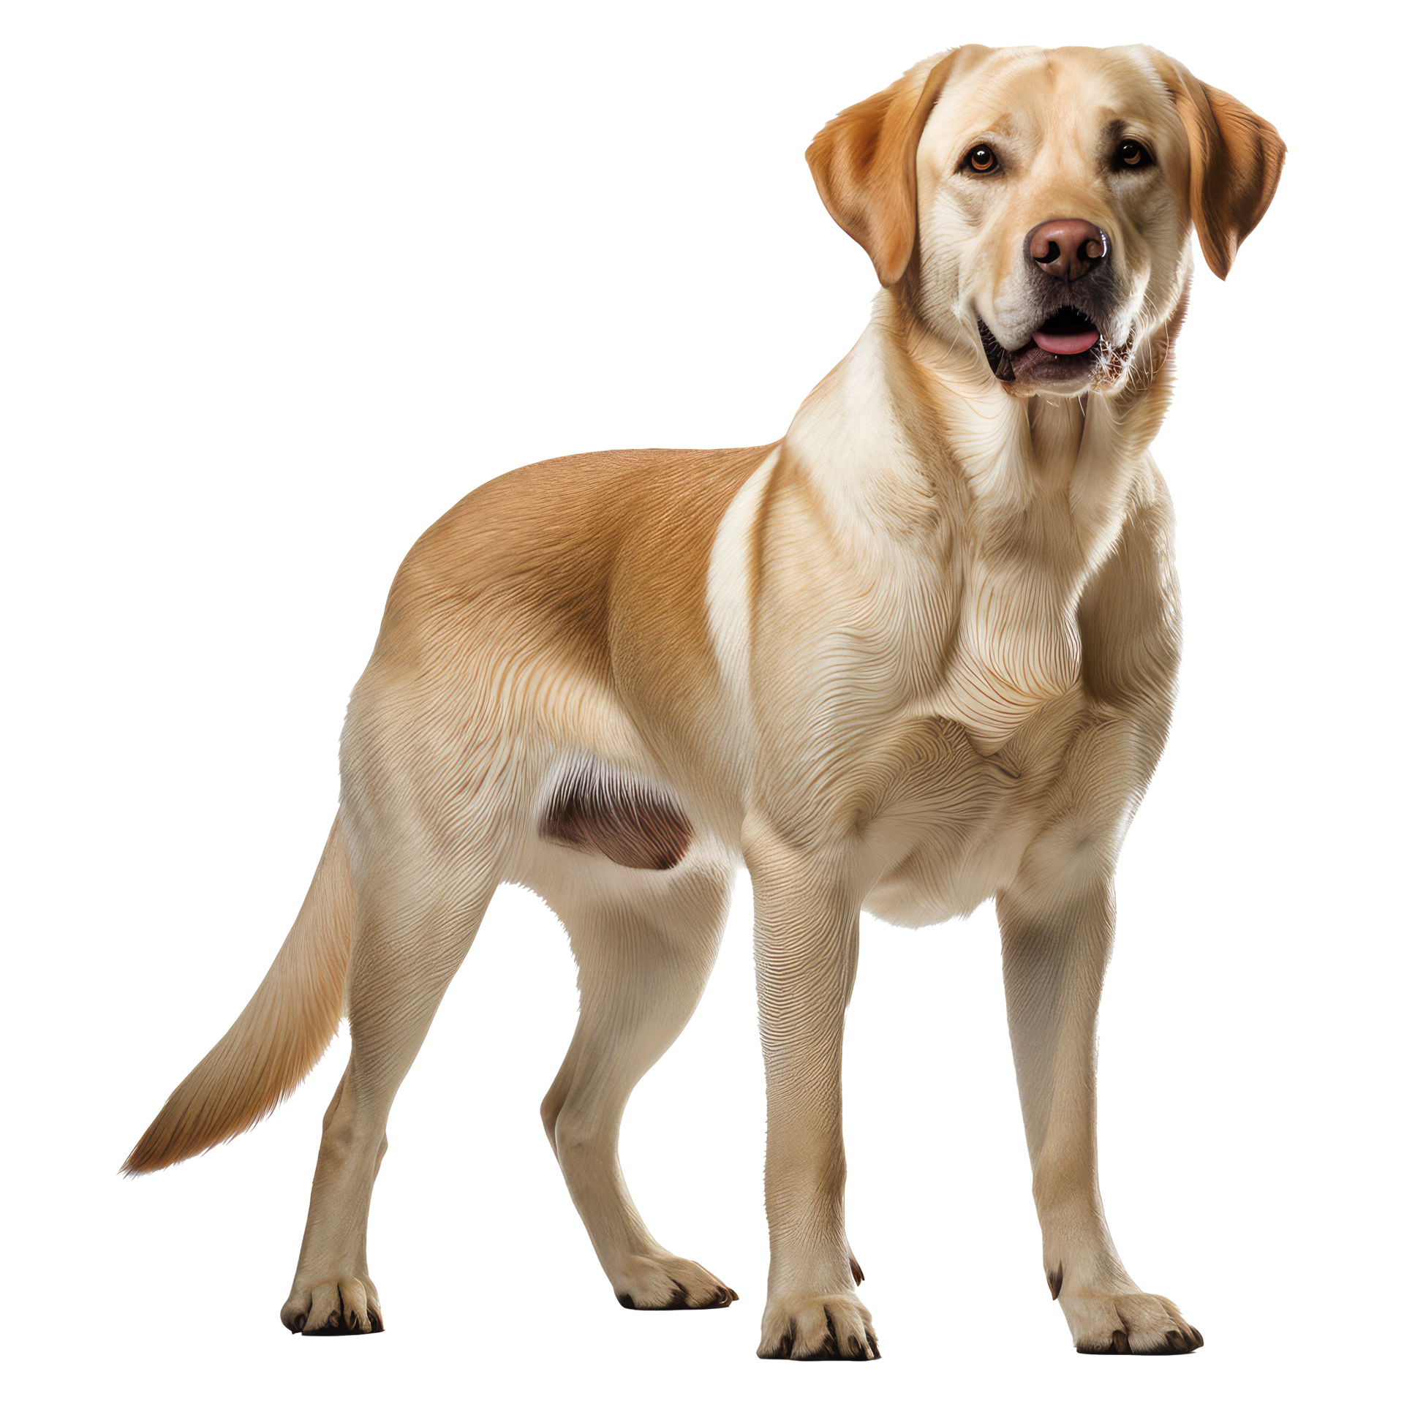

-----------------Result-------------------

Prediction of Model 1 : Dog

Prediction of Model 2 : Dog

Prediction of Model 3 : Dog

Prediction of Model 4 : Dog

Prediction of Model 5 : Dog

------------------------------------------

================================================================

Real Image : dog

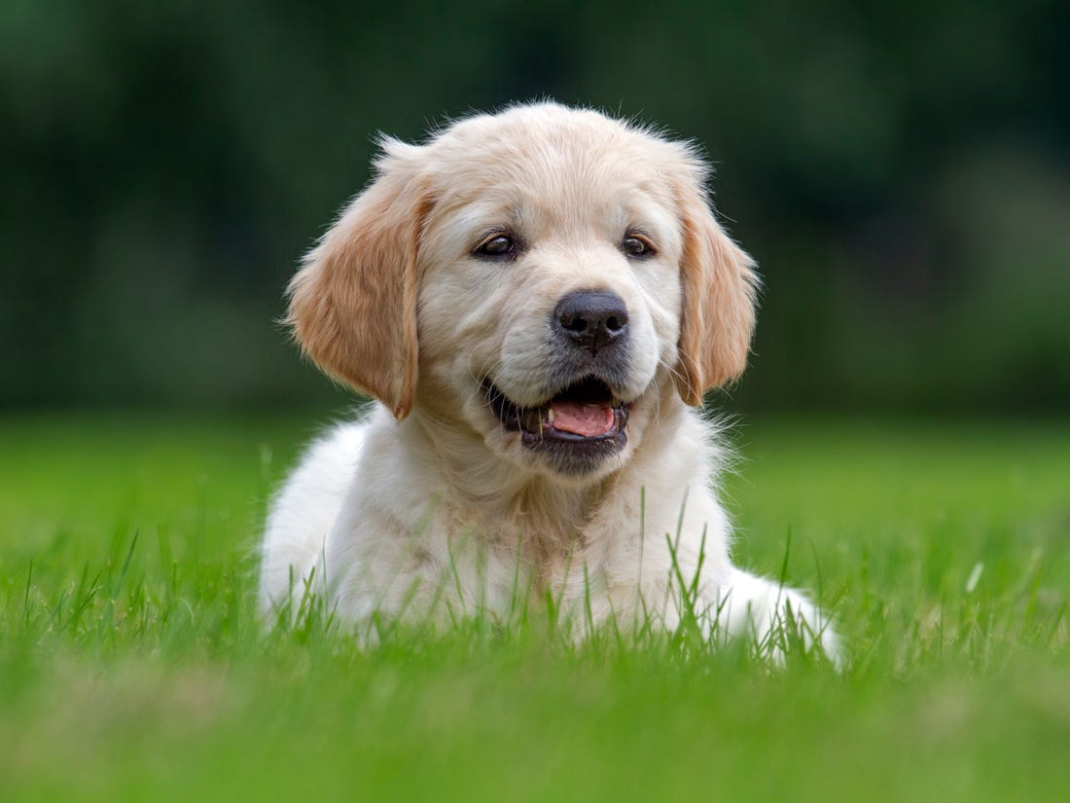

-----------------Result-------------------

Prediction of Model 1 : Dog

Prediction of Model 2 : Dog

Prediction of Model 3 : Dog

Prediction of Model 4 : Dog

Prediction of Model 5 : Dog

------------------------------------------

================================================================

Real Image : dog

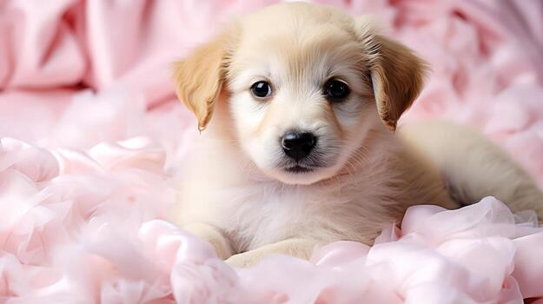

-----------------Result-------------------

Prediction of Model 1 : Dog

Prediction of Model 2 : Dog

Prediction of Model 3 : Dog

Prediction of Model 4 : Dog

Prediction of Model 5 : Dog

------------------------------------------

================================================================

Real Image : dog

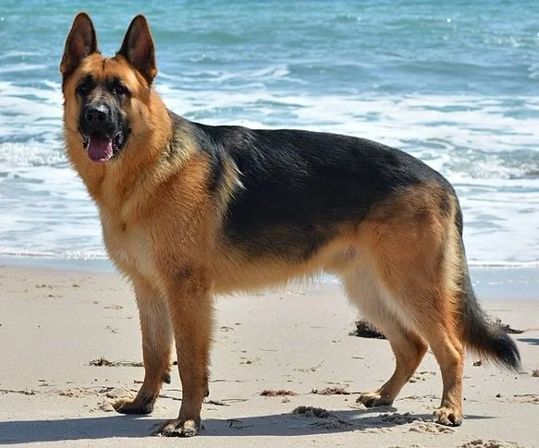

-----------------Result-------------------

Prediction of Model 1 : Dog

Prediction of Model 2 : Dog

Prediction of Model 3 : Dog

Prediction of Model 4 : Dog

Prediction of Model 5 : Dog

------------------------------------------

================================================================

Real Image : dog

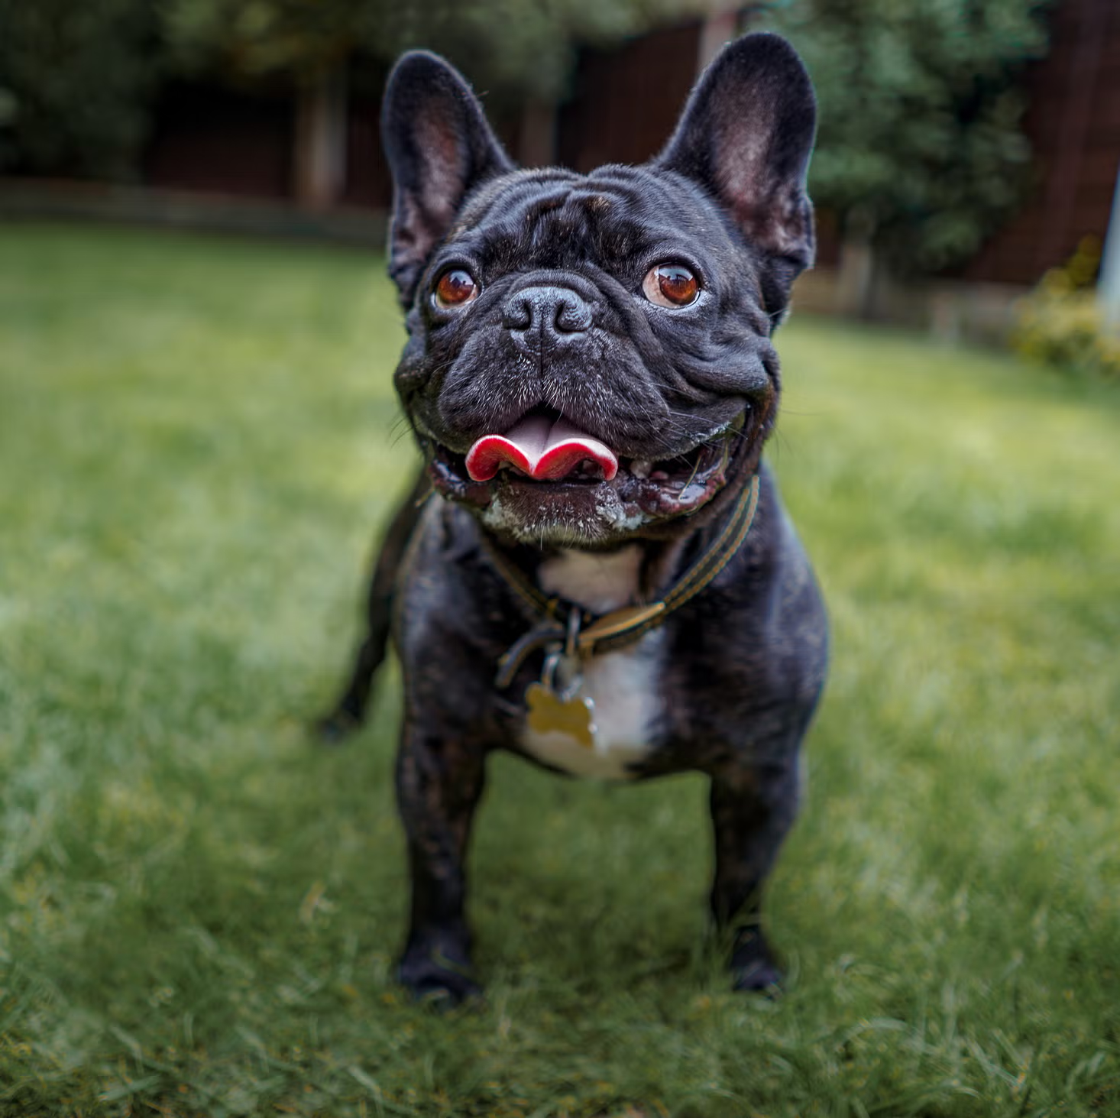

-----------------Result-------------------

Prediction of Model 1 : Dog

Prediction of Model 2 : Dog

Prediction of Model 3 : Dog

Prediction of Model 4 : Dog

Prediction of Model 5 : Dog

------------------------------------------

================================================================

Real Image : dog

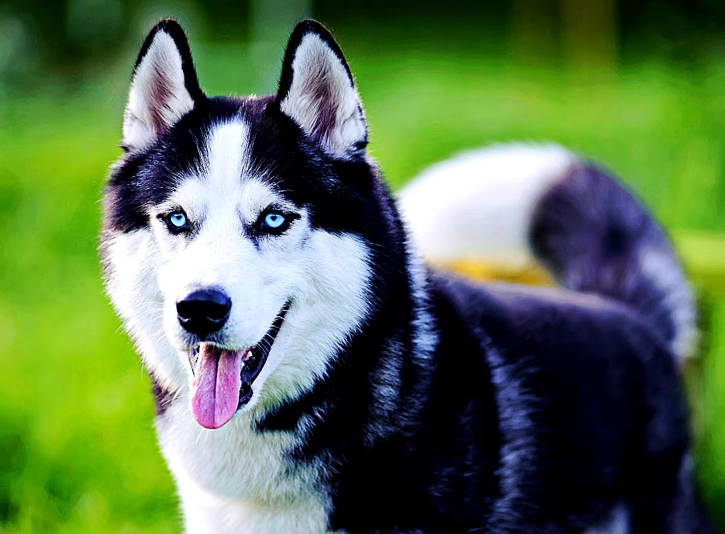

-----------------Result-------------------

Prediction of Model 1 : Dog

Prediction of Model 2 : Dog

Prediction of Model 3 : Dog

Prediction of Model 4 : Dog

Prediction of Model 5 : Dog

------------------------------------------

================================================================

Real Image : dog

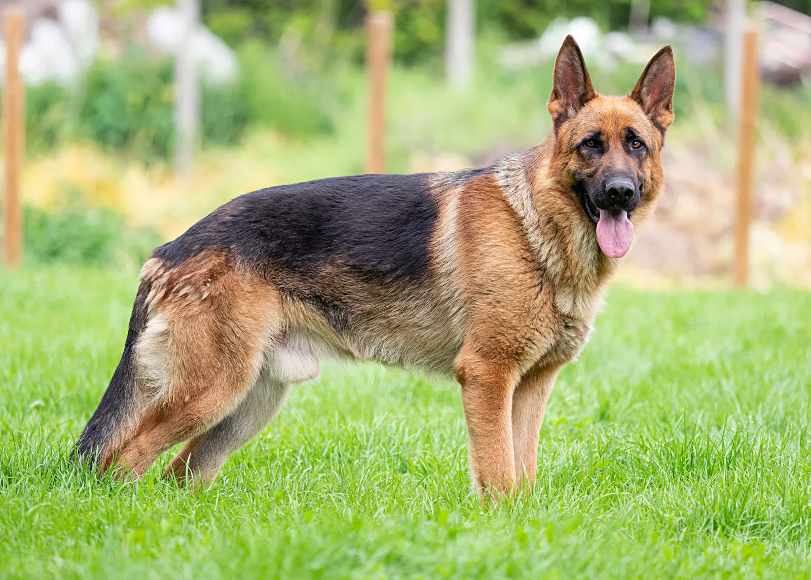

-----------------Result-------------------

Prediction of Model 1 : Dog

Prediction of Model 2 : Dog

Prediction of Model 3 : Dog

Prediction of Model 4 : Dog

Prediction of Model 5 : Dog

------------------------------------------

================================================================

Real Image : dog

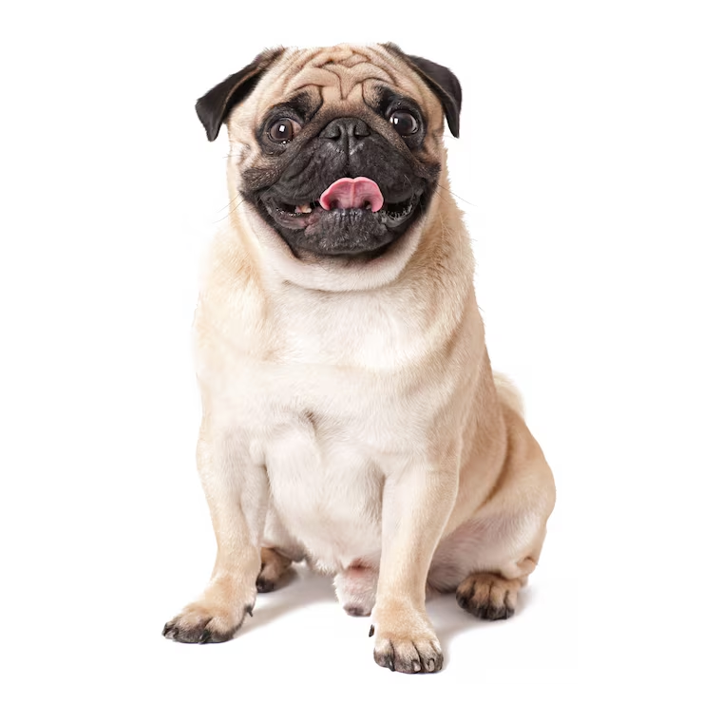

-----------------Result-------------------

Prediction of Model 1 : Dog

Prediction of Model 2 : Dog

Prediction of Model 3 : Dog

Prediction of Model 4 : Dog

Prediction of Model 5 : Dog

------------------------------------------

================================================================

Real Image : dog

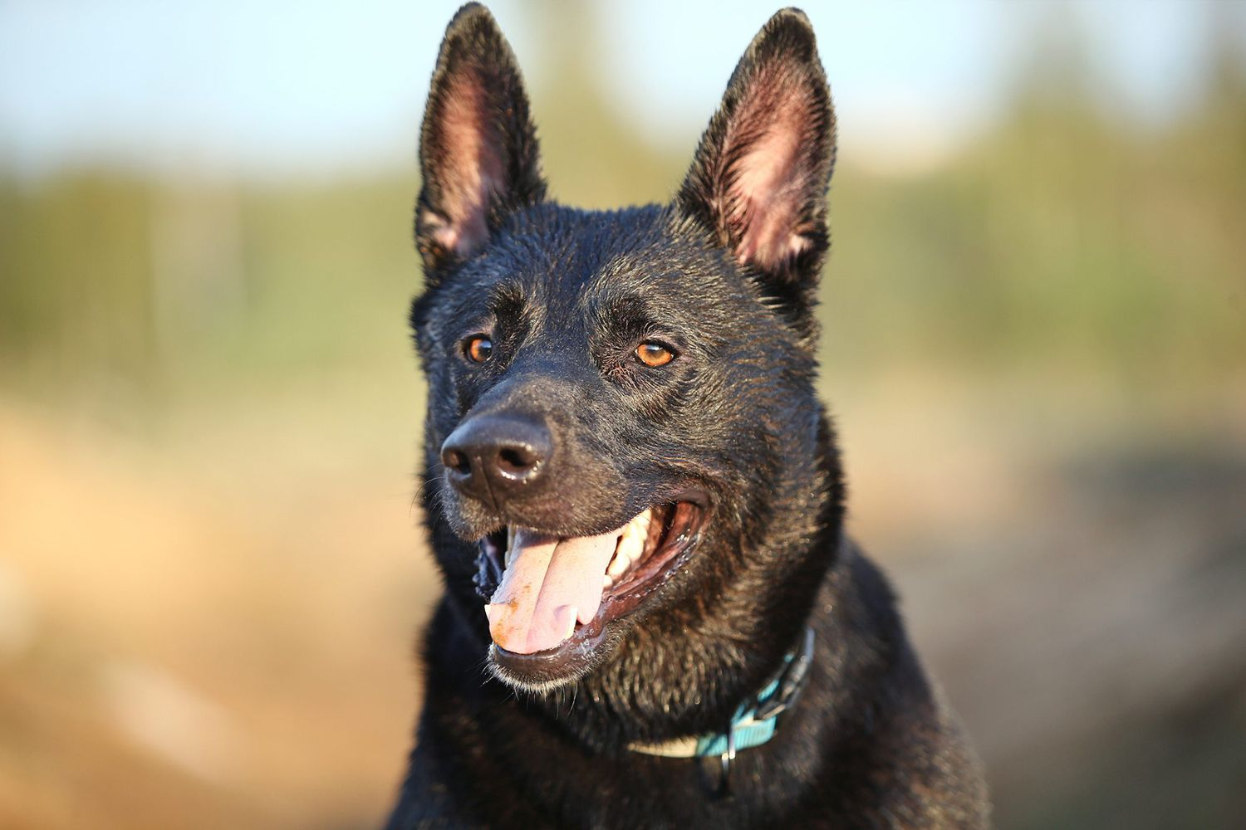

-----------------Result-------------------

Prediction of Model 1 : Cat

Prediction of Model 2 : Dog

Prediction of Model 3 : Cat

Prediction of Model 4 : Dog

Prediction of Model 5 : Dog

------------------------------------------

================================================================

Real Image : dog

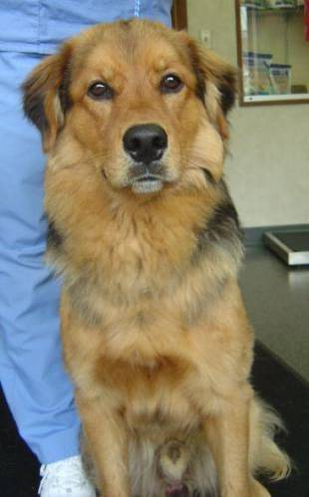

-----------------Result-------------------

Prediction of Model 1 : Dog

Prediction of Model 2 : Dog

Prediction of Model 3 : Dog

Prediction of Model 4 : Dog

Prediction of Model 5 : Dog

------------------------------------------

================================================================

Real Image : dog

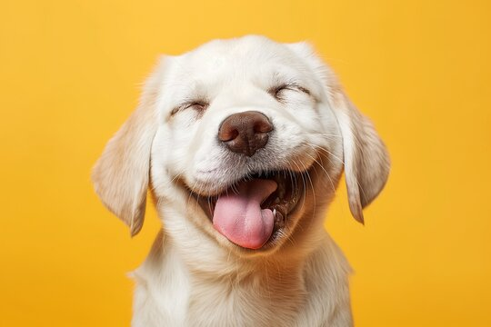

-----------------Result-------------------

Prediction of Model 1 : Dog

Prediction of Model 2 : Dog

Prediction of Model 3 : Dog

Prediction of Model 4 : Cat

Prediction of Model 5 : Dog

------------------------------------------

================================================================

Real Image : dog

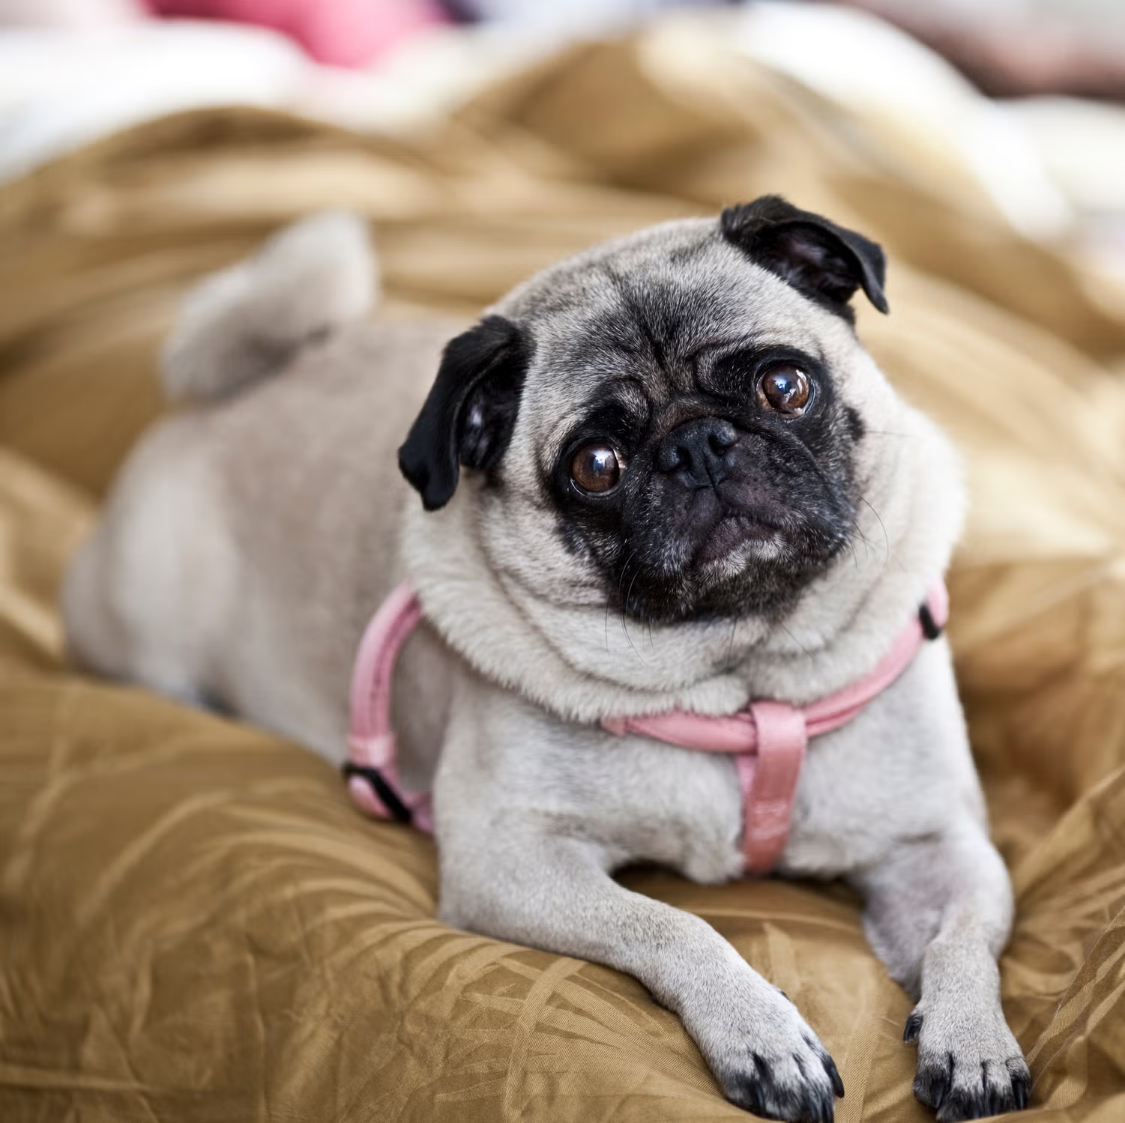

-----------------Result-------------------

Prediction of Model 1 : Dog

Prediction of Model 2 : Dog

Prediction of Model 3 : Dog

Prediction of Model 4 : Dog

Prediction of Model 5 : Dog

------------------------------------------

================================================================

Real Image : dog

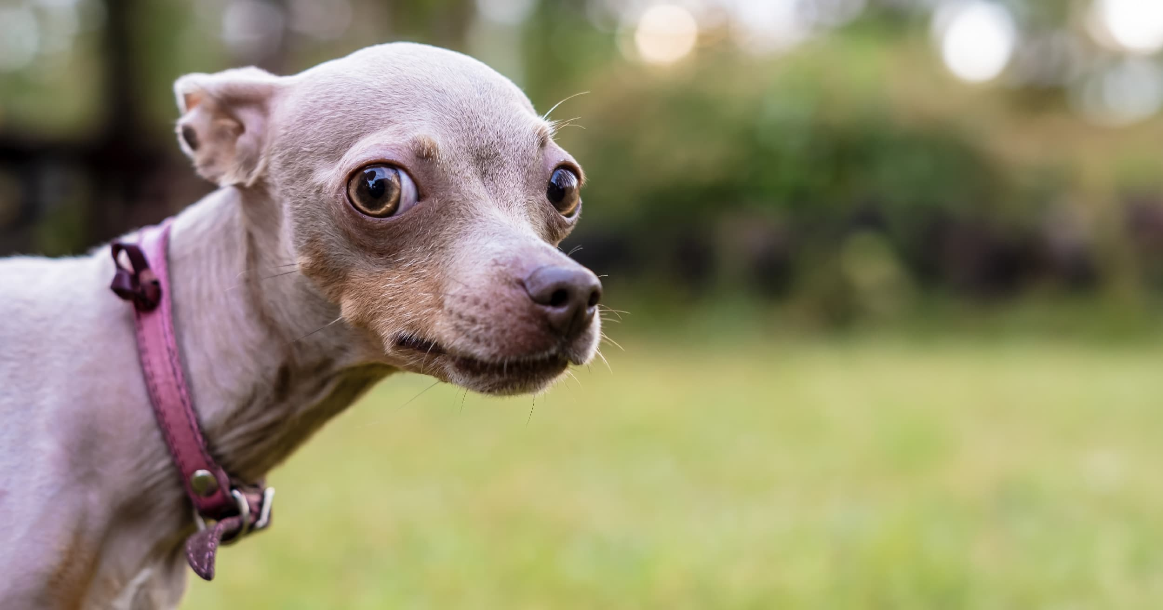

-----------------Result-------------------

Prediction of Model 1 : Dog

Prediction of Model 2 : Dog

Prediction of Model 3 : Dog

Prediction of Model 4 : Dog

Prediction of Model 5 : Dog

------------------------------------------

================================================================

## Final Report

Model 1 (10 epoch) : predicted 22 out of 25

Model 2 (20 epoch) : predicted 22 out of 25

Model 3 (Colab) : predicted 18 out of 25

Model 4 (15 epoch) : predicted 21 out of 25

Model 5 (128_20epoch): predicted 23 out of 25

================================================================